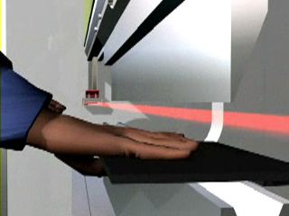
The LZS provides protection at close proximity to workpiece.

